[Type a caption for your photo]  What Does Coaching Choice College have to offer?  - Individualized coach training  - Training in life coaching  - Training in business coaching  - Training in wellness coaching  - Niche area training  - Training in Cognitions of Choice  - The development of assessment skills  - The development of social entrepreneur skills  - Guidance in developing your personalized wellness model of coaching  - Support to launch your coaching business  - Ongoing training and continuing education support |  |  | Who We Are  About Us  Coaching Choice College is a certified coach training program. The program helps develop social entrepreneurs in the areas of life, wellness and business coaching. The coaching model is a means by which you can offer a wellness model as opposed to a “sickness” model. Learn all the tools necessary to launch you wellness coaching business, and make a healthy choice.  Contact Us  Phone: 541 221 3408  Email: csteffen@coachingchoicecollege.com  Web: www.coachingchoicecollege.com  & www.coachingchoicecollege.info  Coaching choice College  335 Main Street  Springfield, OR 97477  541 221 3408 |  |  | Coaching choice College  - Wellness is a choice; choose wellness!

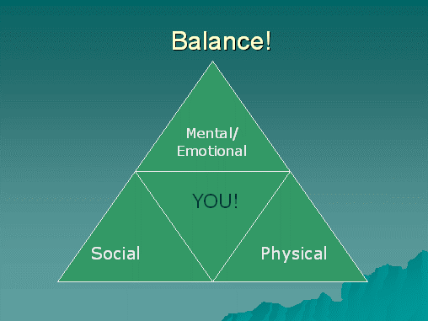  Individualized Training:  The student pursuing training and certification in coaching may choose a specific area of wellness & prevention in which to develop the project and ultimate coaching business. An individual area of study and research is pursued with the intent of developing a coaching business that will provide a viable income source for the student coach upon completion of training and acquisition of the coaching certificate. Growing Social Entrepreneurs is our Business! |  |  | Support for Veterans:  Coaching Choice College Supports our veterans by offering a 50% discount. All other trainees may receive a 10% discount by signing and showing this brochure. Monthly sessions with monthly payment plan options are available upon request.  Testimonial:  I completed the Wellness Coach Training Certificate program with Choice College in April, 2012. It was a wonderful one on one experience which made it possible to not only receive an in depth review of the subject matter, but as critical, I was afforded many discussions exploring specific opportunities for development of my personal coaching business. Clare Steffen, Ed.D., BCC is a genuinely seasoned and caring teacher and practitioner. I would recommend this program to those professionals who are expanding their psychology practices as well as those who are leaving managed care.  Robin Muskal, Ph.D.  Certified Wellness Coach |  |  | 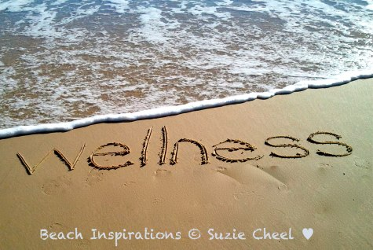  [Type a caption for your photo]  Foundational Training Program:  East Meets West (30 hours) This program explores the marriage between an allopathic and holistic approach to coaching. The program provides an in-depth examination of the core competencies. This foundational program is included in the 60 hour training program, Designing Personal Relationships by Choice.  Designing Personal Relationships by Choice (60 hours)  Building on the foundational training, in this program the trainee receive both the East Meets West program along with incorporating the wellness model into the development of healthy relationships. The new choice thinking model is applied to use Cognitions of Choice, assess for wellness, and build confidence in coaching clients.

